Description of the Product
90 HP ELECTRIC OUTBOARD MOTOR

SEAGÖ SE90 series is an electric outboard motor has a rated voltage of 144V, and the maximum power is 66 kW. Compared to the existing gasoline models, the electric outboard is quieter and more environmentally friendly because they run on electricity instead of fuel. Additionally, we use Permanent Magnet Synchronous Motors, which have reduced noise, extended lifespan, increased efficiency and require less maintenance.
Relevant Boat Class
Small vessels of various materials including inflatable boats, wooden boats, FRP boats, plastic boats and similar, with lengths ranging from 4 Metres above, are a good fit for the electric 90-horsepower outboard motor.
Recommended Battery
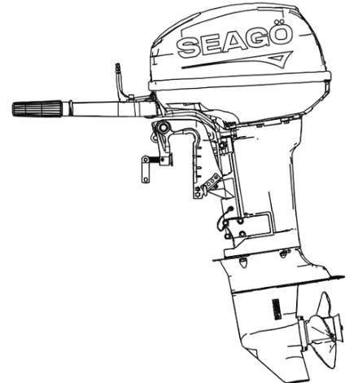
For this Model, 144V 400 AH LiFePO4 – Lithium Ferrous Phosphate battery packs can be utilized
Model Options
SE90A0(All in one) – Short/Medium/Long
Adjustable transom Height
Specifications

Product Model | SE90AO
Rated Power | 66 kW
Rated Voltage | 144 V
Motor Type | PMSM
Sensor Type | Magnetic Encoder
Control System | Steering Grip - Steering Wheel Controls
Maximum Speed | 4500-5500 RPM
Gear Ratio | 1.85(24:13)
Transom Height | 508mm(max)
Weight {Kg} | 115 Kg
Cooling System | Freshwater Closed-loop
Gear Position | Forward /Standing /Shift

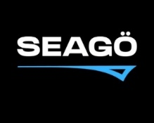
www.seago.in sales@seago.in +91-8606366633
90 HP ELECTRIC OUTBOARD MOTOR

